TASK 1

PACKET IDENTIFICATION
USING WIRESHARK
Computer Networks Laboratory

Student Name | Kasireddy Srihitha
Roll No. | 2520030153
Section | Sec - 7

1. AIM
To capture network traffic using Wireshark and identify the total number of captured packets, TCP packets, UDP packets, ICMP packets, and the major protocols visible in the Protocol Hierarchy.

2. SOFTWARE REQUIRED
Wireshark Network Protocol Analyzer (version 4.6.9) and a computer connected to a network.

3. PROCEDURE
- Opened Wireshark and selected the Wi-Fi network interface.
- Started a live packet capture and generated network traffic by accessing websites.
- Stopped the capture and saved the packet capture as CN_Lab1.pcapng.
- Observed the total packet count in the Wireshark status bar.
- Applied the display filters tcp, udp, and icmp separately to identify the corresponding packet counts.
- Opened Statistics → Protocol Hierarchy to inspect the protocols represented in the capture.

4. OBSERVATIONS AND RESULTS
The following values were read from the saved capture and the Wireshark display-filter status bar.
S. No. | Observation | Packets
1 | Total packets captured | 69,290
2 | TCP packets (display filter: tcp) | 7,044
3 | UDP packets (display filter: udp) | 39,916
4 | ICMP packets (display filter: icmp) | 0
Note: The icmp display filter checks IPv4 ICMP. The capture's Protocol Hierarchy also shows 86 ICMPv6 packets. ICMP and ICMPv6 are separate protocol filters in Wireshark.

5. PROTOCOL HIERARCHY
The Protocol Hierarchy window groups protocols by encapsulation. The major protocol entries observed in this capture include UDP, mDNS, IPv4, IPv6, and TCP. The hierarchy is nested, so parent and child packet counts can overlap and should not be added together.
Protocol entry | Packet count shown / derived | Explanation
UDP | 39,916 | IPv6 UDP 14,194 + IPv4 UDP 25,722
mDNS | 33,046 | IPv6 mDNS 13,274 + IPv4 mDNS 19,772
IPv4 | 32,914 | Internet Protocol Version 4 row
IPv6 | 14,366 | Internet Protocol Version 6 row
TCP | 7,044 | Transmission Control Protocol row
The counts above are taken from the visible Protocol Hierarchy entries in the supplied screenshot. UDP and mDNS totals are combined across their IPv4 and IPv6 branches; they are not separate top-level categories. The hierarchy window itself is the evidence for these entries.

6. SCREENSHOT EVIDENCE
The screenshots below document the capture and each analysis step. Each figure is labelled to show exactly what the screenshot demonstrates.
SCREENSHOT 1: WIRESHARK PACKET CAPTURE AND TOTAL PACKET COUNT
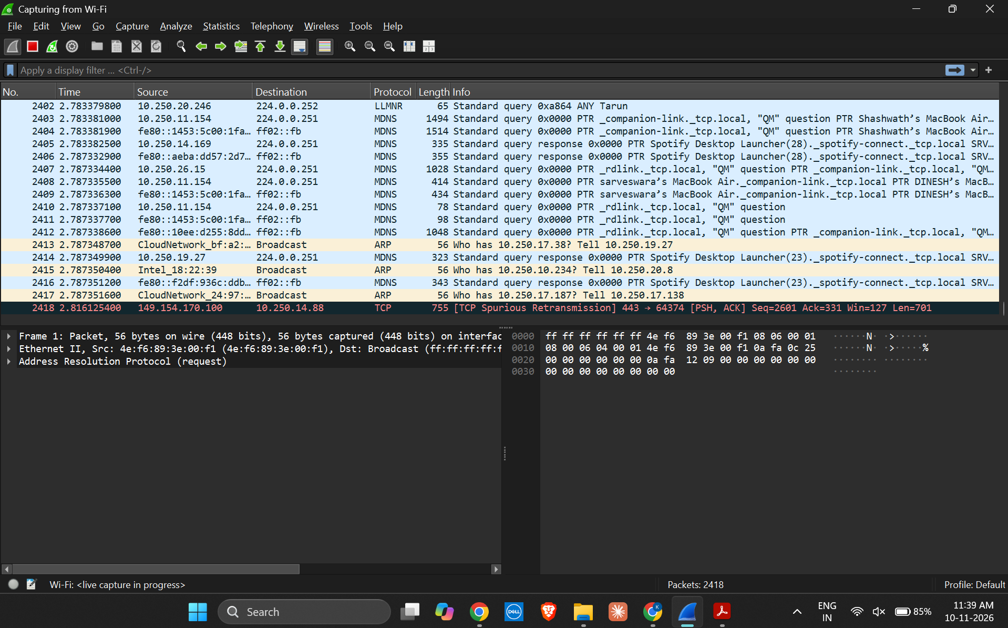
Figure 1. Wireshark live capture on the Wi-Fi interface. Use this image as evidence of packet capture; the final saved-file view shows the total of 69,290 packets.
SCREENSHOT 2: TCP PACKET FILTER RESULT
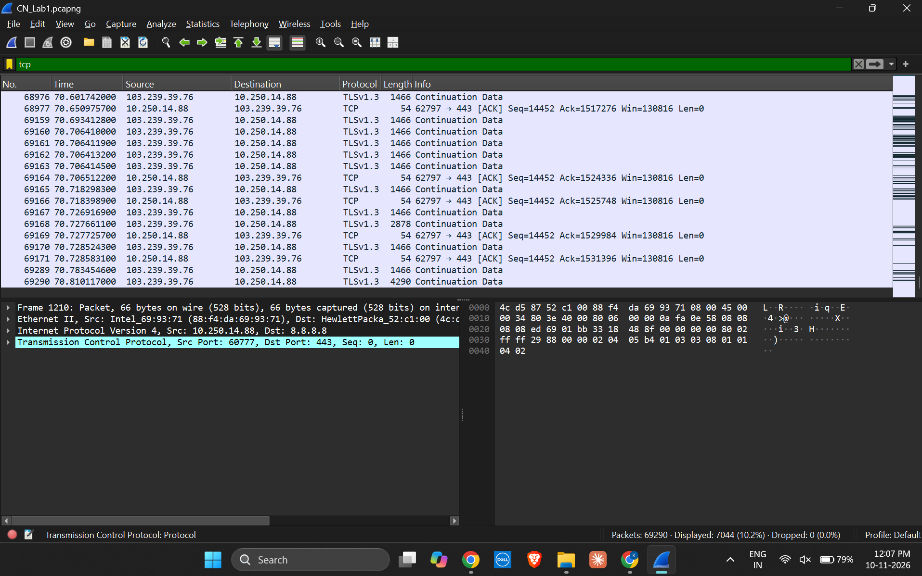
Figure 2. Display filter tcp applied. The status bar shows 7,044 displayed packets.
SCREENSHOT 3: UDP PACKET FILTER RESULT
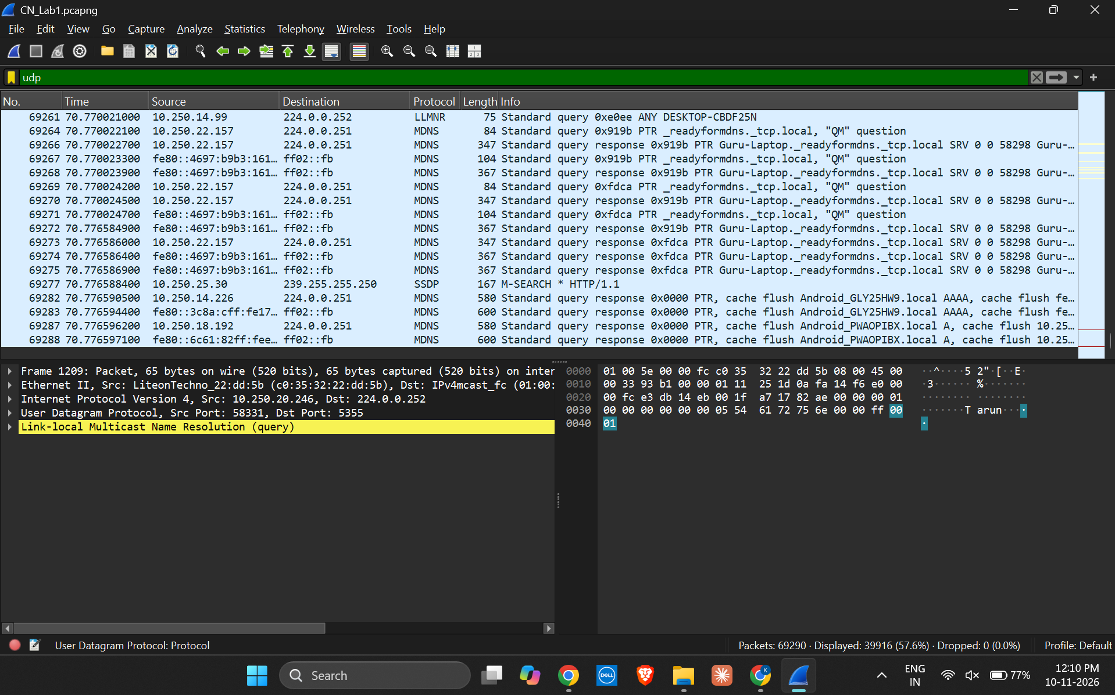
Figure 3. Display filter udp applied. The status bar shows 39,916 displayed packets.
SCREENSHOT 4: ICMP PACKET FILTER RESULT
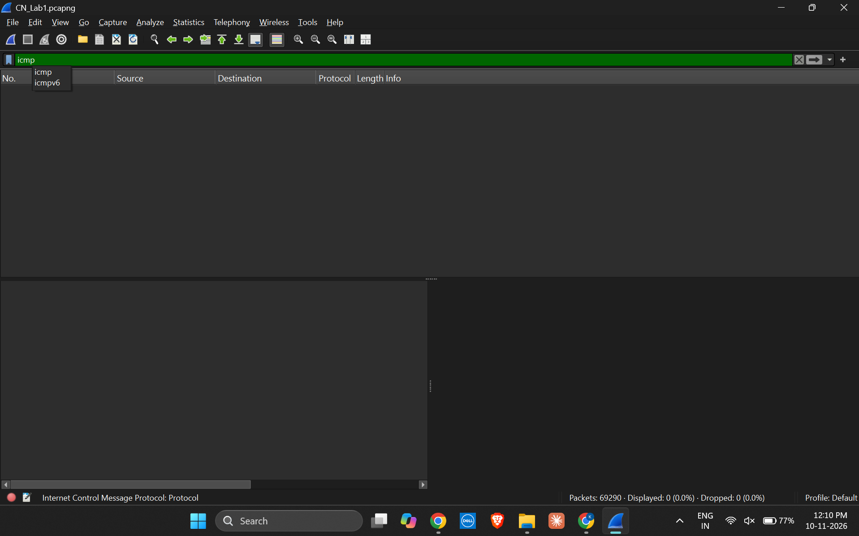
Figure 4. Display filter icmp applied. The status bar shows 0 displayed packets.
SCREENSHOT 5: PROTOCOL HIERARCHY STATISTICS
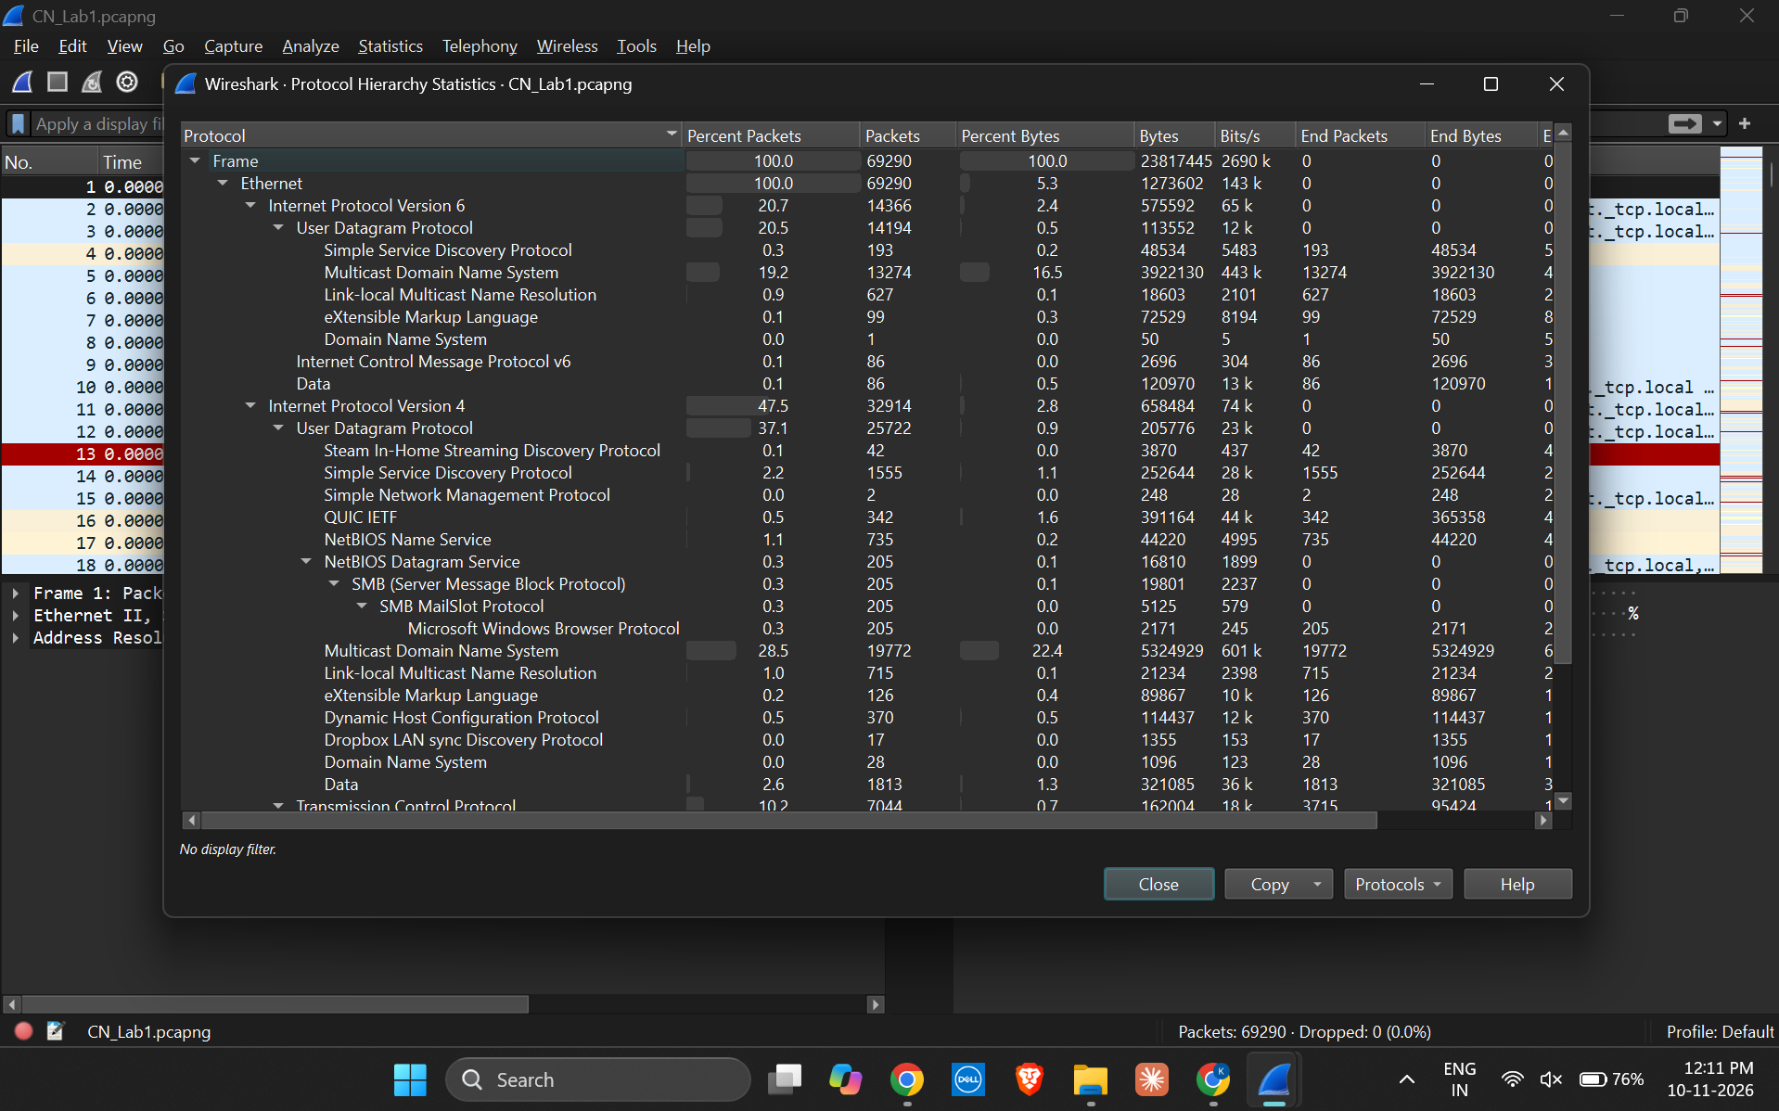
Figure 5. Statistics → Protocol Hierarchy window showing protocol names, packet counts, and percentages.

7. RESULT
Network traffic was successfully captured and analyzed using Wireshark. The total packet count and TCP, UDP, and ICMP filter results were recorded. The Protocol Hierarchy was examined to identify the major protocols present in the capture.

8. FILE DETAILS
Capture file: CN_Lab1.pcapng
Submission reminder: Keep the original .pcapng file with the report if the instructor requires the raw capture. Review it for device names, IP addresses, and other network details before uploading it to a public GitHub repository.

